Unit 10
Artificial Intelligence


- Reading 1:
What Is AI?
- Reading Comprehension
- Skill of the Unit:
➢How to explain a theory

- Reading 2:
➢Artificial Intelligence Challenges What It Means to Be Creative
- Translation
- Further Discussion
Looking Back
Looking Forward


Looking Back

What Is AI?
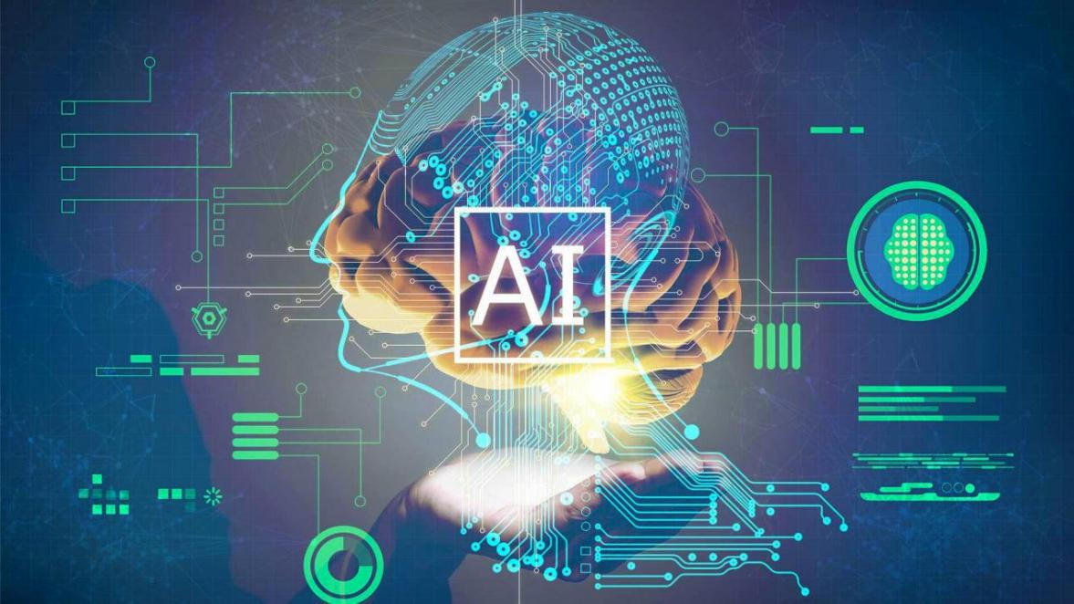
(Artificial intelligence, or AI, is technology that enables computers and machines to simulate human intelligence and problem-solving capabilities.)
- On its own or combined with other technologies (e.g., sensors, geolocation, robotics) AI can perform tasks that would otherwise require human intelligence or intervention. Digital assistants, GPS guidance, autonomous vehicles, and generative AI tools (like Open AI's Chat GPT) are just a few examples of AI in the daily news and our daily lives.
- As a field of computer science, artificial intelligence encompasses (and is often mentioned together with) machine learning and deep learning. These disciplines involve the development of AI algorithms, modeled after the decision-making processes of the human brain, that can ‘learn’ from available data and make increasingly more accurate classifications or predictions over time.
- Artificial intelligence has gone through many cycles of hype, but even to skeptics, the release of ChatGPT seems to mark a turning point. The last time generative AI loomed this large, the breakthroughs were in computer vision, but now the leap forward is in natural language processing (NLP). Today, generative AI can learn and synthesize not just human language but other data types including images, video, software code, and even molecular structures.
- Applications for AI are growing every day. But as the hype around the use of AI tools in business takes off, conversations around ai ethics and responsible ai become critically important. For more on where IBM stands on these issues, please read Building trust in AI.
Types of artificial intelligence: weak AI vs. strong AI
- Weak AI—also known as narrow AI or artificial narrow intelligence (ANI)—is AI trained and focused to perform specific tasks. Weak AI drives most of the AI that surrounds us today. "Narrow" might be a more apt descriptor for this type of AI as it is anything but weak: it enables some very robust applications, such as Apple's Siri, Amazon's Alexa, IBM watsonx™, and self-driving vehicles.
- Strong AI is made up of artificial general intelligence (AGI) and artificial super intelligence (ASI). AGI, or general AI, is a theoretical form of AI where a machine would have an intelligence equal to humans; it would be self-aware with a consciousness that would have the ability to solve problems, learn, and plan for the future. ASI—also known as superintelligence—would surpass the intelligence and ability of the human brain. While strong AI is still entirely theoretical with no practical examples in use today, that doesn't mean AI researchers aren't also exploring its development. In the meantime, the best examples of ASI might be from science fiction, such as HAL, the superhuman and rogue computer assistant in 2001: A Space Odyssey.
Deep learning vs. machine learning
- Machine learning and deep learning are sub-disciplines of AI, and deep learning is a sub-discipline of machine learning.
- Both machine learning and deep learning algorithms use neural networks to ‘learn’ from huge amounts of data. These neural networks are programmatic structures modeled after the decision-making processes of the human brain. They consist of layers of interconnected nodes that extract features from the data and make predictions about what the data represents.
- Machine learning and deep learning differ in the types of neural networks they use, and the amount of human intervention involved. Classic machine learning algorithms use neural networks with an input layer, one or two ‘hidden’ layers, and an output layer. Typically, these algorithms are limited to supervised learning: the data needs to be structured or labeled by human experts to enable the algorithm to extract features from the data.
- Deep learning algorithms use deep neural networks—networks composed of an input layer, three or more (but usually hundreds) of hidden layers, and an output layout. These multiple layers enable unsupervised learning: they automate extraction of features from large, unlabeled and unstructured data sets. Because it doesn’t require human intervention, deep learning essentially enables machine learning at scale.
The rise of generative models
- Generative AI refers to deep-learning models that can take raw data—say, all of Wikipedia or the collected works of Rembrandt—and “learn” to generate statistically probable outputs when prompted. At a high level, generative models encode a simplified representation of their training data and draw from it to create a new work that’s similar, but not identical, to the original data.
- Generative models have been used for years in statistics to analyze numerical data. The rise of deep learning, however, made it possible to extend them to images, speech, and other complex data types. Among the first class of AI models to achieve this cross-over feat were variational autoencoders, or VAEs, introduced in 2013. VAEs were the first deep-learning models to be widely used for generating realistic images and speech.
- “VAEs opened the floodgates to deep generative modeling by making models easier to scale,” said Akash Srivastava, an expert on generative AI at the MIT-IBM Watson AI Lab. “Much of what we think of today as generative AI started here.”
- Early examples of models, including GPT-3, BERT, or DALL-E 2, have shown what’s possible. In the future, models will be trained on a broad set of unlabeled data that can be used for different tasks, with minimal fine-tuning. Systems that execute specific tasks in a single domain are giving way to broad AI systems that learn more generally and work across domains and problems. Foundation models, trained on large, unlabeled datasets and fine-tuned for an array of applications, are driving this shift.
- As to the future of AI, when it comes to generative AI, it is predicted that foundation models will dramatically accelerate AI adoption in enterprise. Reducing labeling requirements will make it much easier for businesses to dive in, and the highly accurate, efficient AI-driven automation they enable will mean that far more companies will be able to deploy AI in a wider range of mission-critical situations. For IBM, the hope is that the computing power of foundation models can eventually be brought to every enterprise in a frictionless hybrid-cloud environment.


Reading Comprehension
Part A: Paraphrasing and Creating
- Please use your own words to paraphrase the underlined sentences in the following passage.
As a field of computer science, artificial intelligence encompasses (and is often mentioned together with) machine learning and deep learning. These disciplines involve the development of AI algorithms, modeled after the decision-making processes of the human brain, that can ‘learn’ from available data and make increasingly more accurate classifications or predictions over time.

____________________________________________________________________

____________________________________________________________________

____________________________________________________________________
Part B. Skimming and Scanning
Look at the following statements and the list of AI models below. Match each statement with the correct AI model.
N.B. Some statement may be matched with both of the AI models.
2. __________ automates feature extraction from large, unstructured datasets.
3. __________ limited to supervised learning with human intervention.
4. __________ uses neural networks with more hidden layers.
5. __________ employs neural networks modeled after the human brain.
A. Machine Learning
B. Deep Learning

Part C: Generalizing and Summarizing
Complete the summary below. Choose one or two words from the passage for each answer.
Generative AI refers to deep-learning models that generate new outputs based on 6.__________, such as Wikipedia or works by Rembrandt, by learning statistically probable patterns. Initially used for numerical data analysis in statistics, generative models have extended to complex data types like images and speech with the advent of 7. __________. Variational autoencoders (VAEs), introduced in 2013, were the first models to generate realistic images and speech effectively. These models paved the way for more advanced generative AI models, including GPT-3, BERT, and DALL-E 2. The future of AI envisions foundation models trained on large, unlabeled datasets to perform various tasks with minimal fine-tuning. This shift will enhance AI adoption across 8._________ by reducing labeling requirements and enabling accurate, efficient automation.

The original article is available at https://www.ibm.com/topics/artificial-intelligence

